**Submitted by : Spogmai Jan**

**Roll No : 2430 - 0081**

**Submitted to : Sir Bilal Dar**

**LAB TASK 01**

**TASK 01: ICS NUMBERS**

**Logic Gates**

|  |  |  |
| --- | --- | --- |
| Ics number | Ic name | description |
| 7400 | Quad 2-input NAND Gate | Contains four 2-input NAND gates. |
| 7402 | Quad 2-input NOR Gate | Contains four 2-input NOR gates. |
| 7404 | Hex Inverter (NOT Gate) | Contains six NOT gates (inverters) |
| 7408 | Quad 2-input AND Gate | |  | | --- | |  |  |  | | --- | | Contains four 2-input AND gates. | |
| 7432 | Quad 2-input OR Gate | |  | | --- | |  |  |  | | --- | | Contains four 2-input OR gates. | |
| 7410 | Triple 3-input NAND Gate | |  | | --- | |  |  |  | | --- | | Contains three 3-input NAND gates. | |
| 7420 | Dual 4-input NAND Gate | Contains two 4-input NAND gates. |

**Flip flop and latches** :

|  |  |  |
| --- | --- | --- |
| Ic number | Ic name | description |
| 7474 | |  | | --- | | Dual D-type Flip-Flop |  |  | | --- | |  | | Contains two D-type flip-flops with reset and set. |
| 7475 | 4-bit Register with Parallel Load | |  | | --- | |  |  |  | | --- | | Contains four D-type flip-flops in a register form | |

**Arthimetic units :**

|  |  |  |
| --- | --- | --- |
| **Ic number** | **Ic name** | **description** |
| 7483 | 4-bit Binary Full Adder | 4-bit binary full adder for adding two 4-bit numbers |
| 74181 | |  | | --- | | 4-bit ALU (Arithmetic Logic Unit) |  |  | | --- | |  | | |  | | --- | |  |  |  | | --- | | Performs basic arithmetic and logic operations. | |

**Task 02 :**

**Implement the push button on single LED**

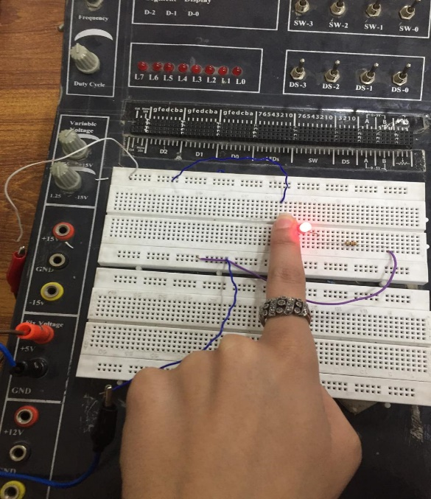

**Task 03 :**

**Implement the push button on multiple LEDS**

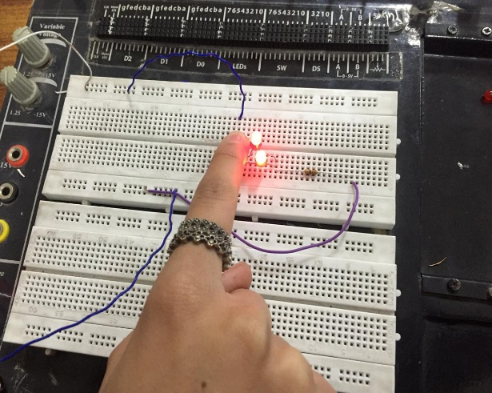

**------ THE END ------**